**Office 365 Excel Download and Installation Steps :**

First, create a microsoft account :([link](https://login.live.com/))

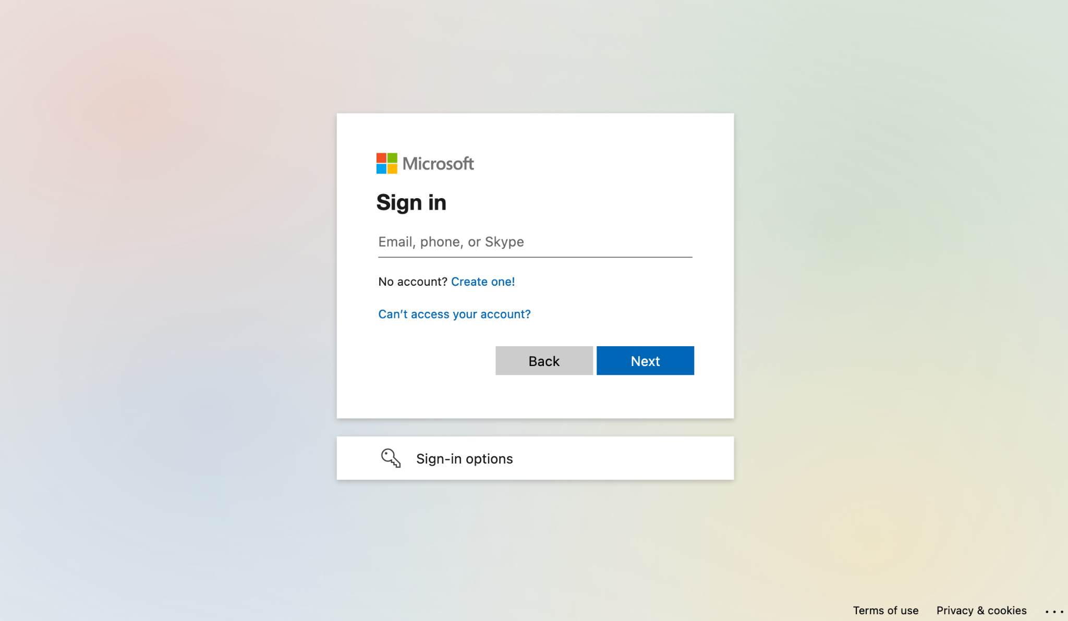

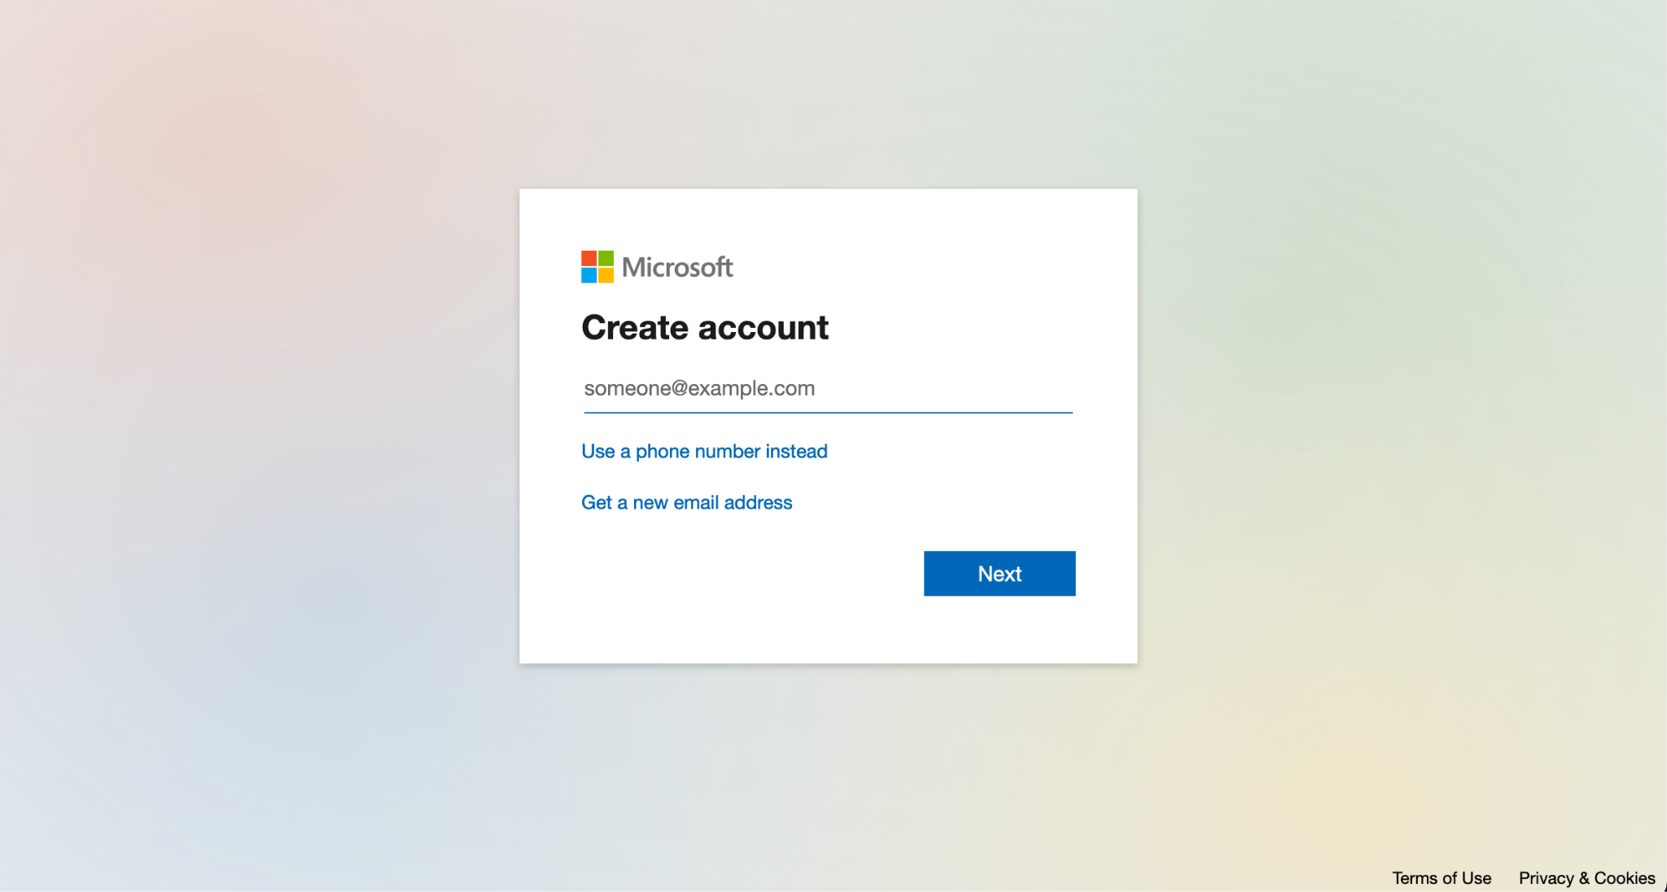

Click Get new email address (select from outlook/live)

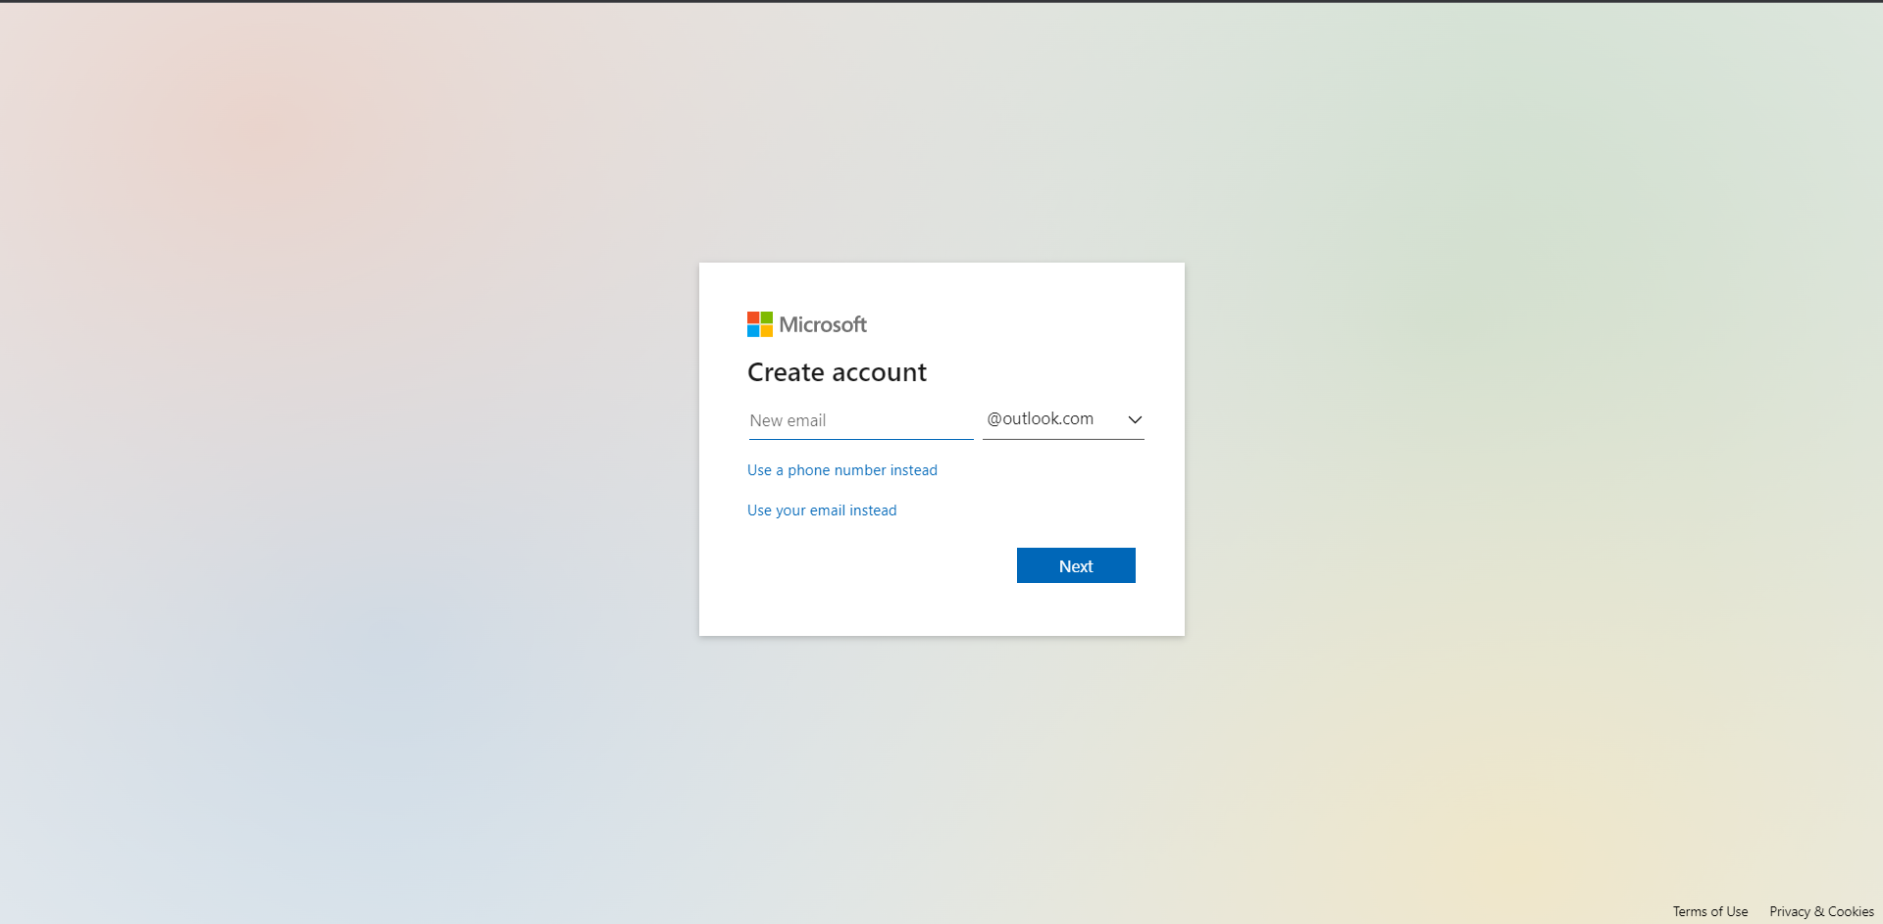

Create password and fill in basic details

Account created.

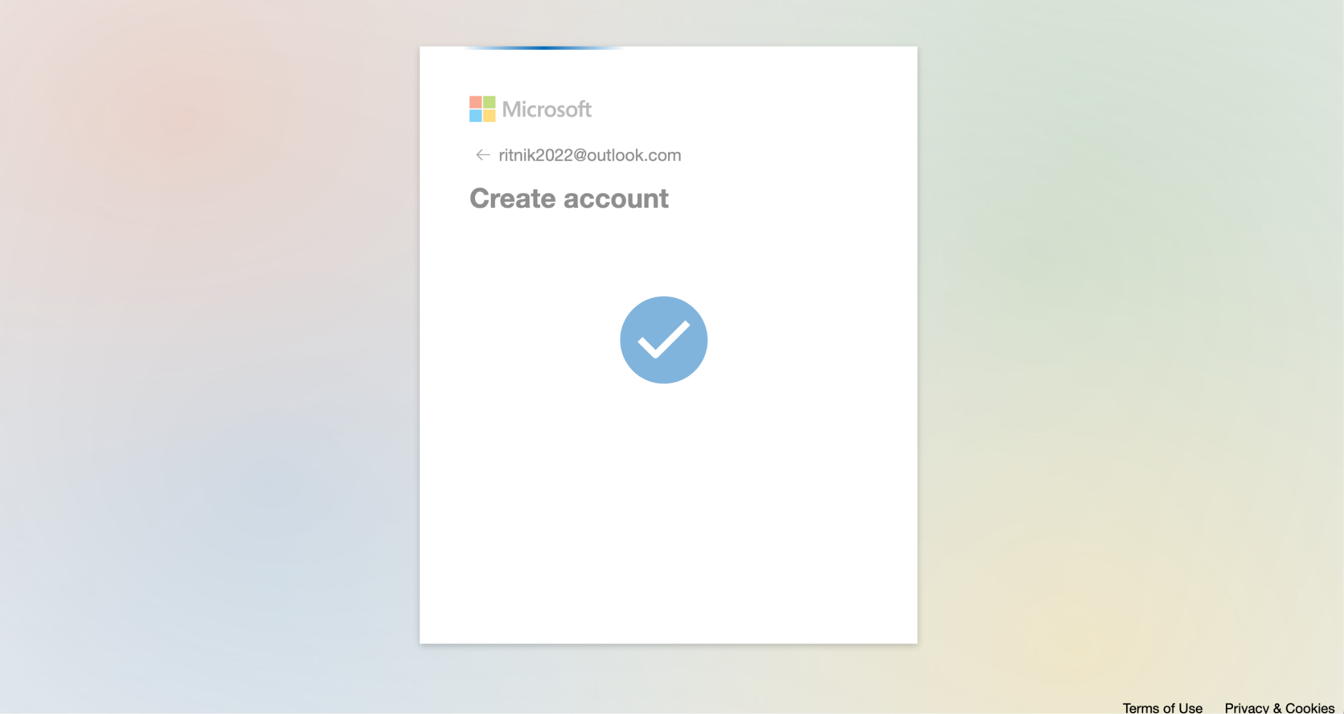

Now we will create an Office 365 Developer Account.

Go to <https://developer.microsoft.com/en-us/microsoft-365/dev-program>

Click Join now and login in with the microsoft account that we created above

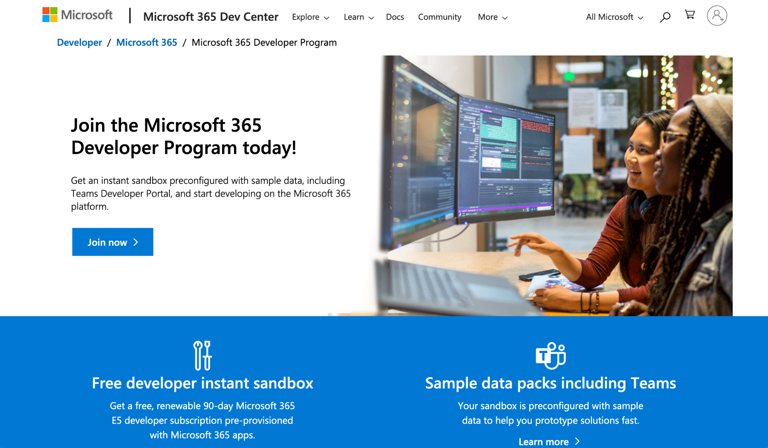

Fill in the details and click on next

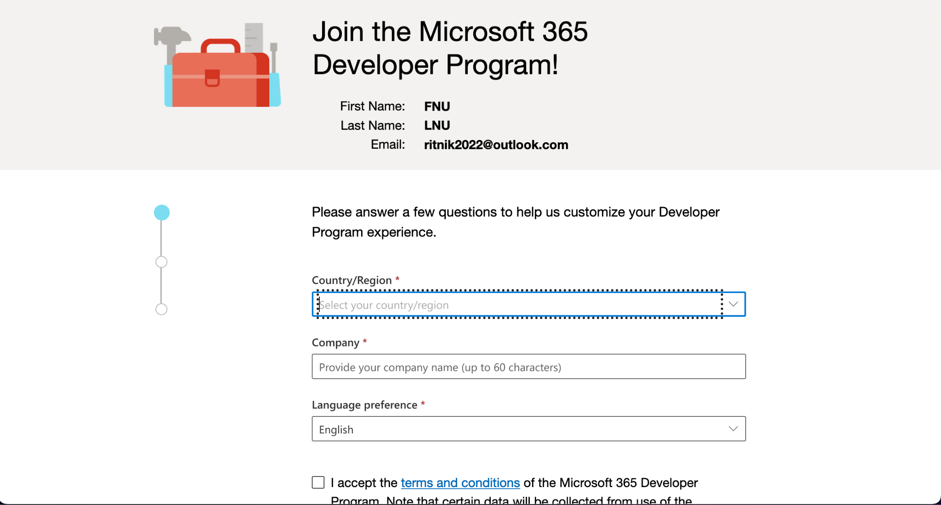

Preferable to choose personal projects from the below mentioned options

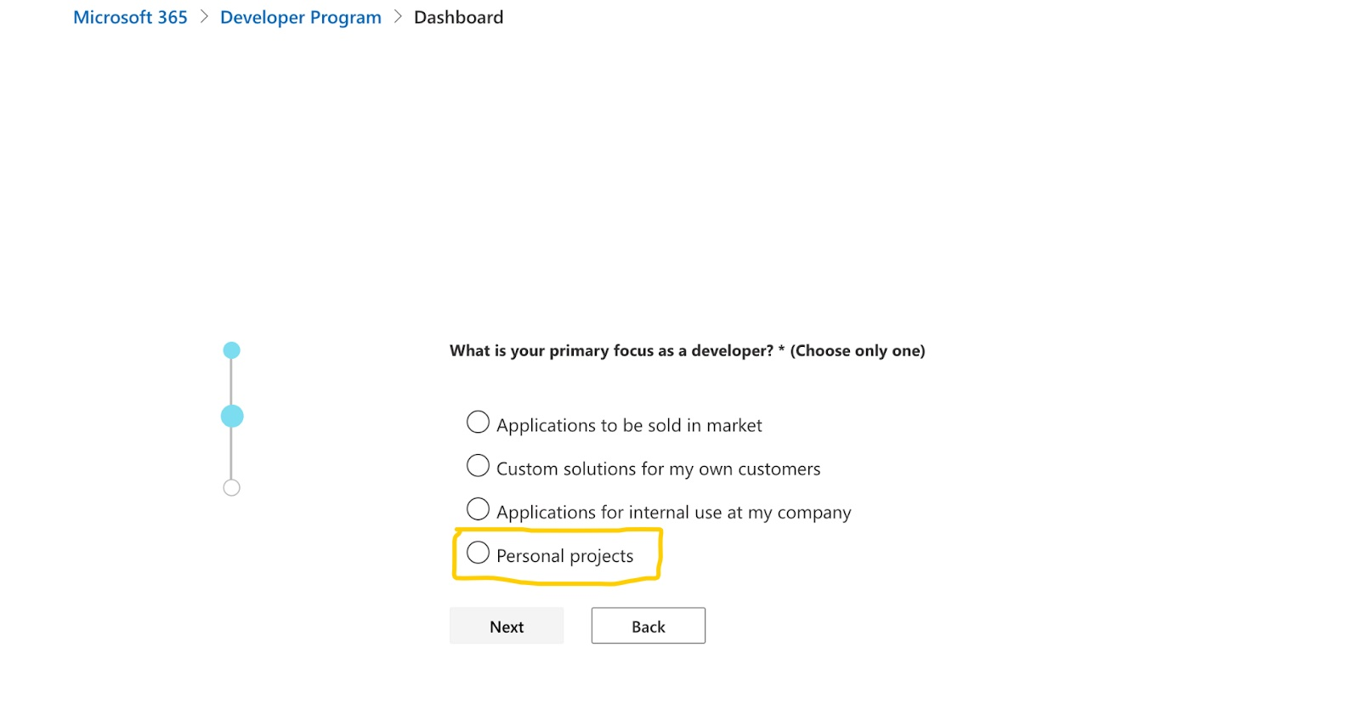

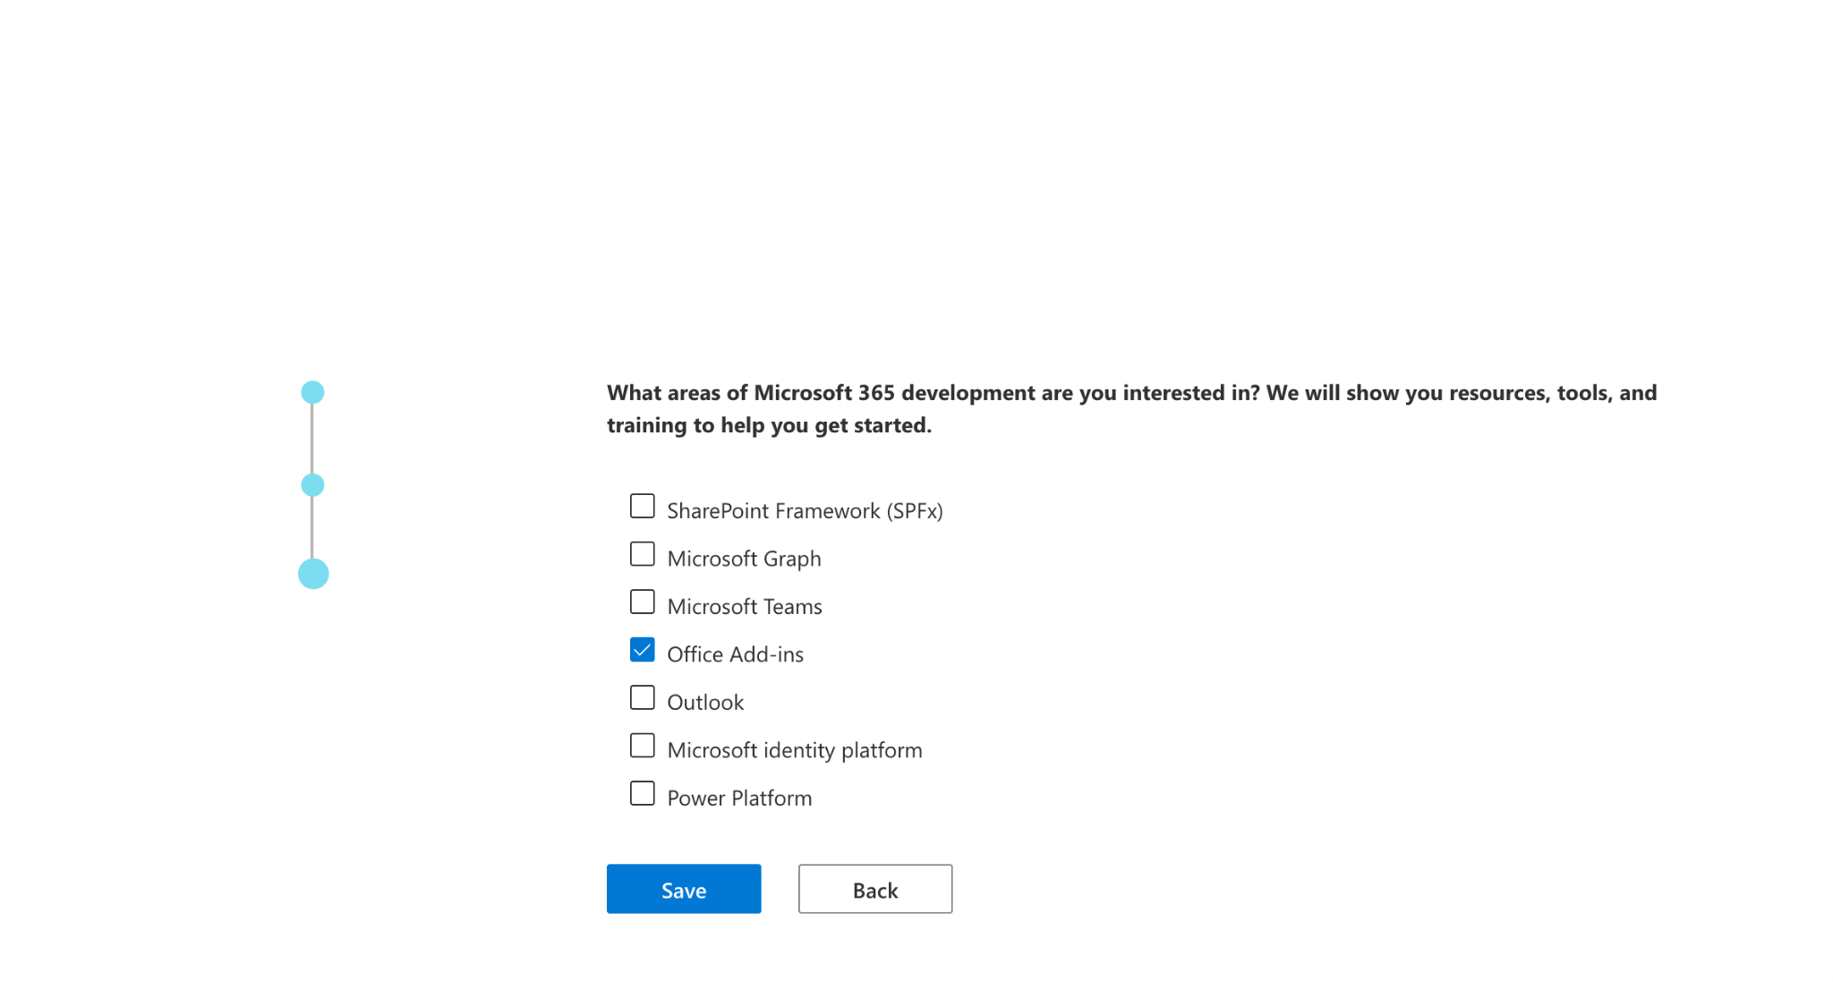

Select Instant sandbox and click Next

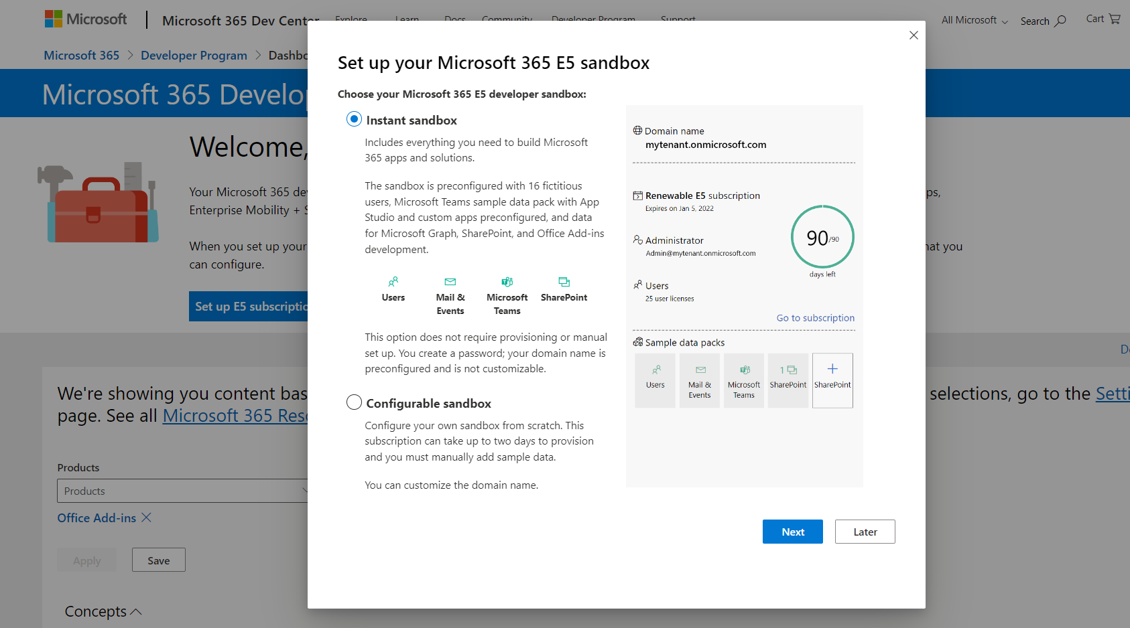

Click on Continue once all the details are added

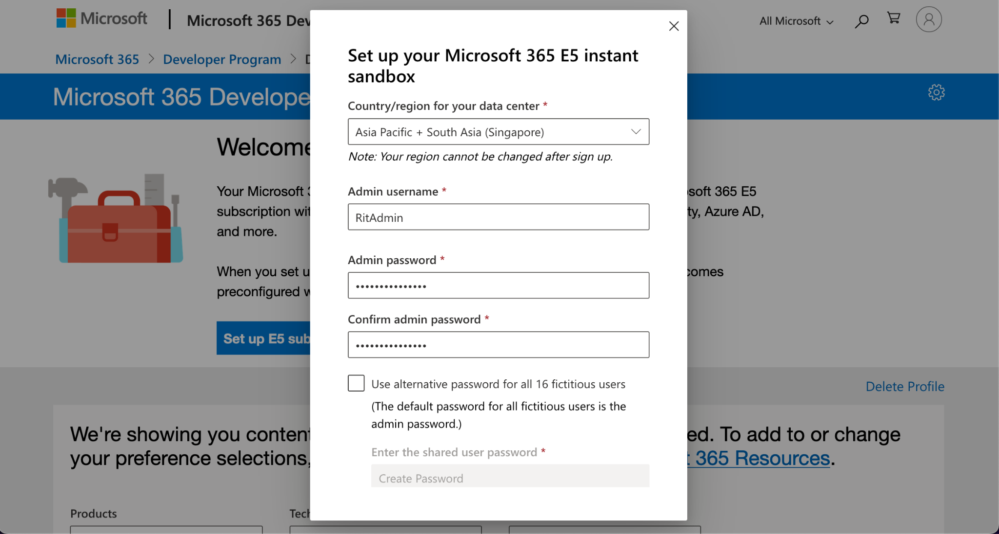

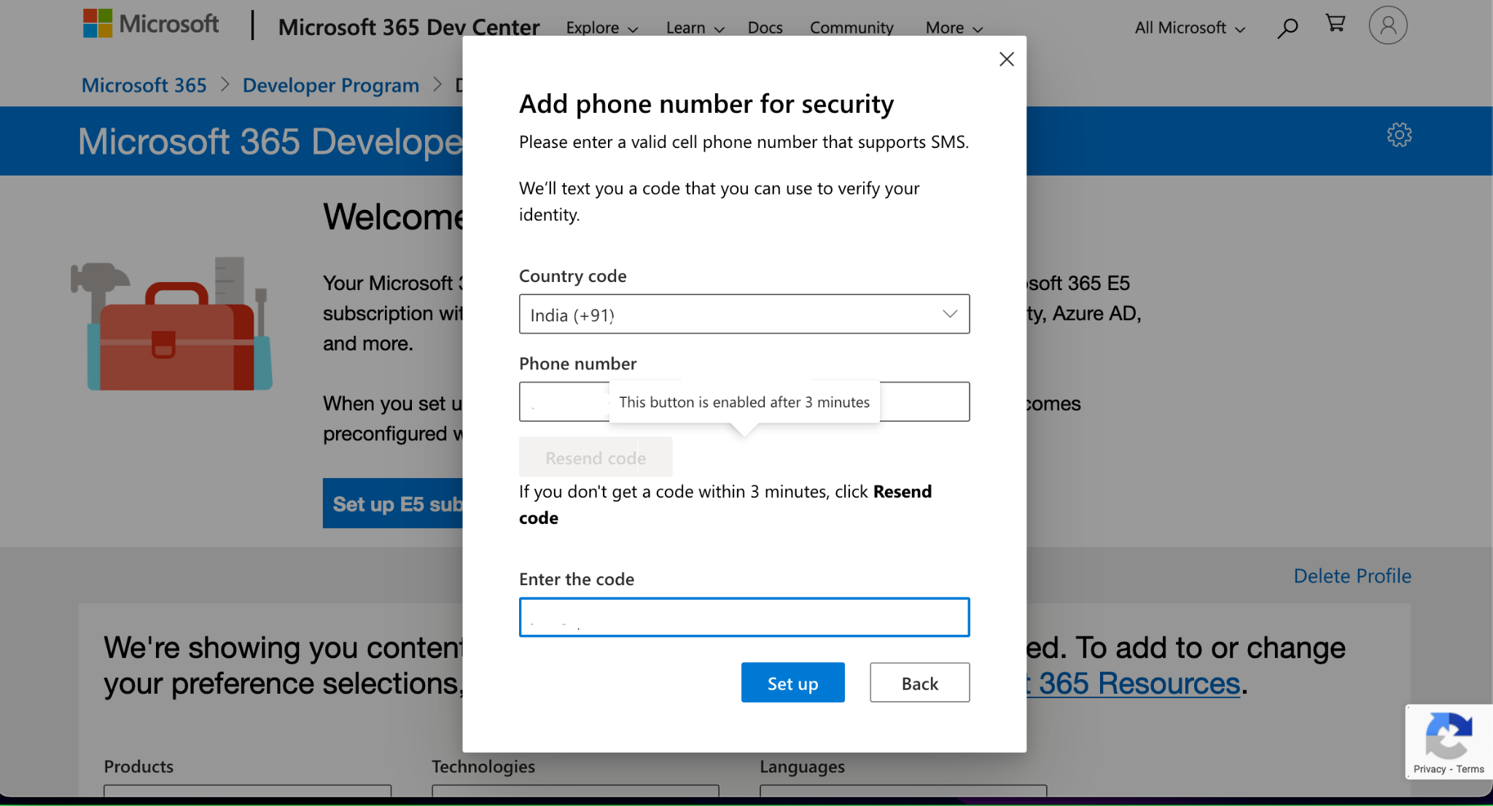

Once everything is setup you will see below interface

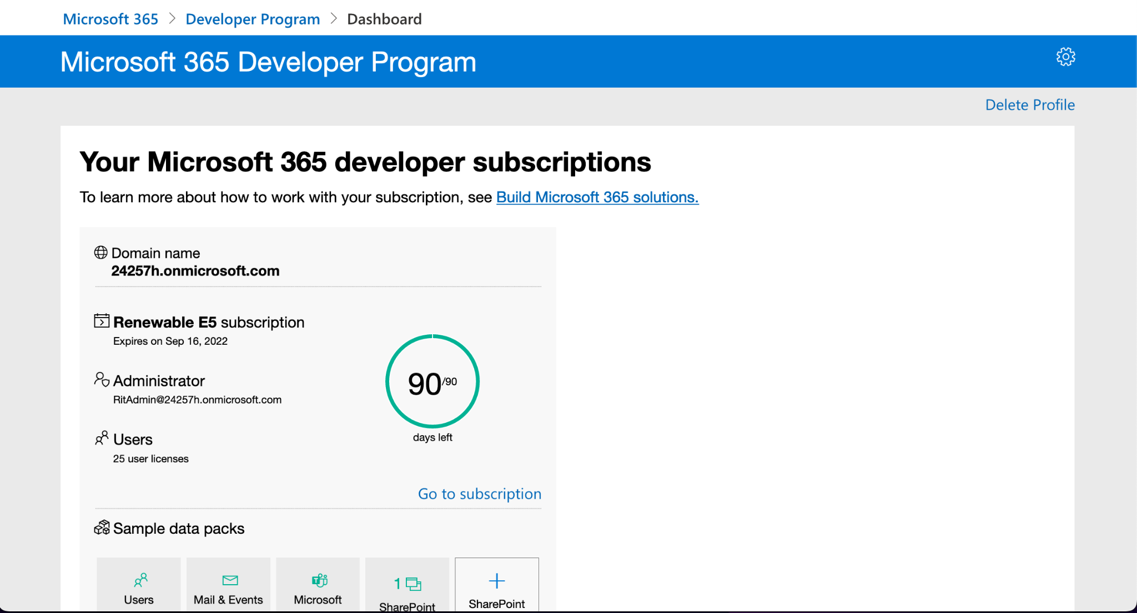

Copy the administrator email

Redirect to :

<https://www.office.com/?acctsw=1&auth=2>

Paste the administrator email and use the admin password that you had created above

Login to Dev A/c :

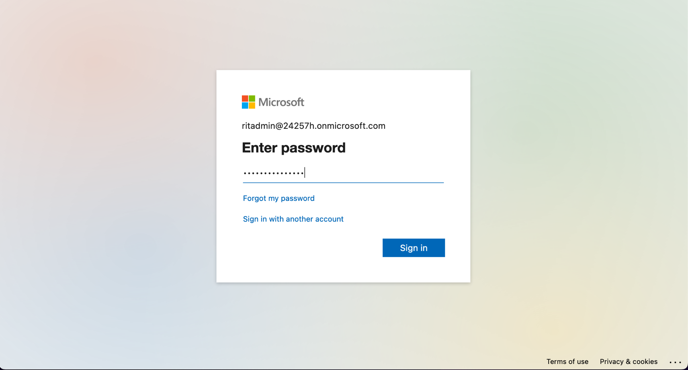

Two step authentication has to be done :

1. Download Microsoft Authenticator App on Android/IOS from Google Play/App Store. Scan the QR code to authenticate the account. ([link](https://play.google.com/store/apps/details?id=com.azure.authenticator&hl=en_IN&gl=US))
   1. Click on the 3 vertical dot icon at the top right corner
   2. Click on add account
   3. Click on work or school account
   4. Select Scan QR code
   5. Click on approve to setup the 2 factor authentication
   6. Click next and verify your phone number

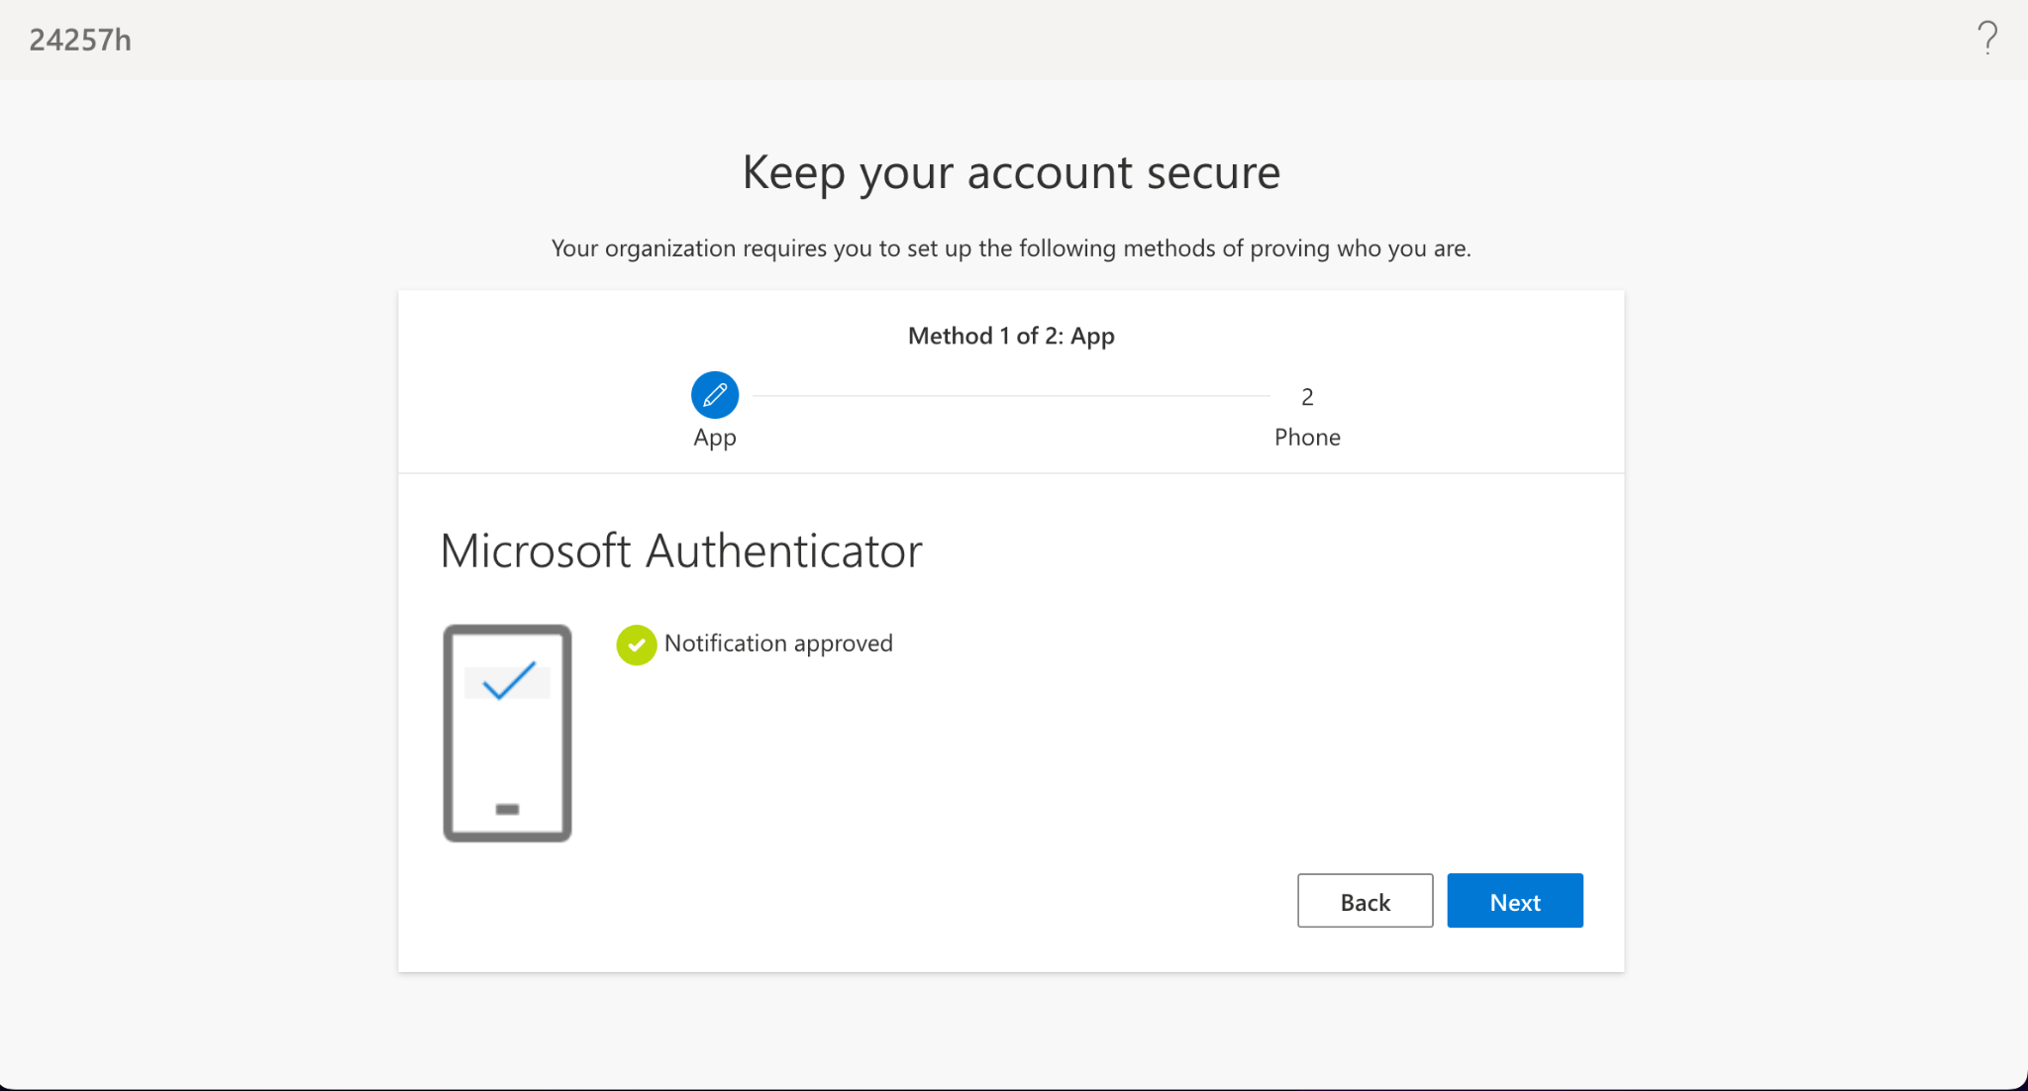

1. Verify the OTP sent on the mobile number.

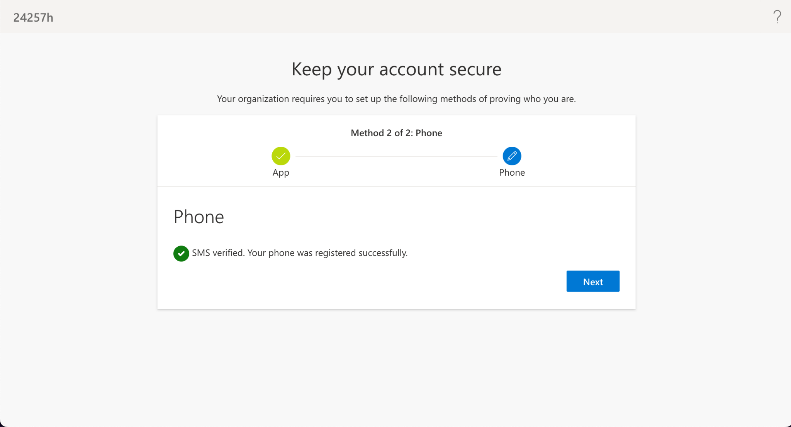

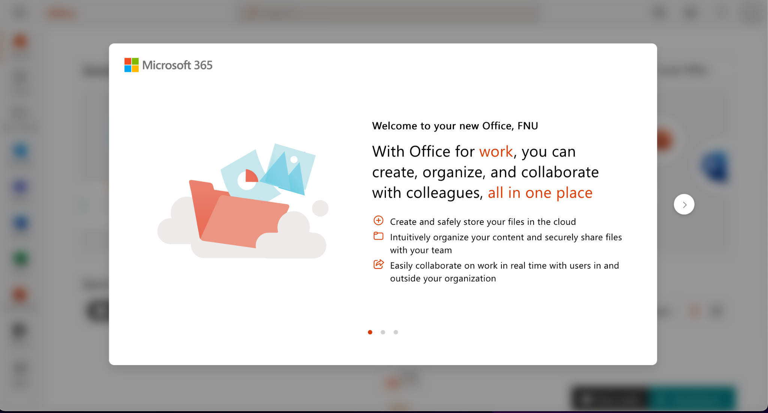

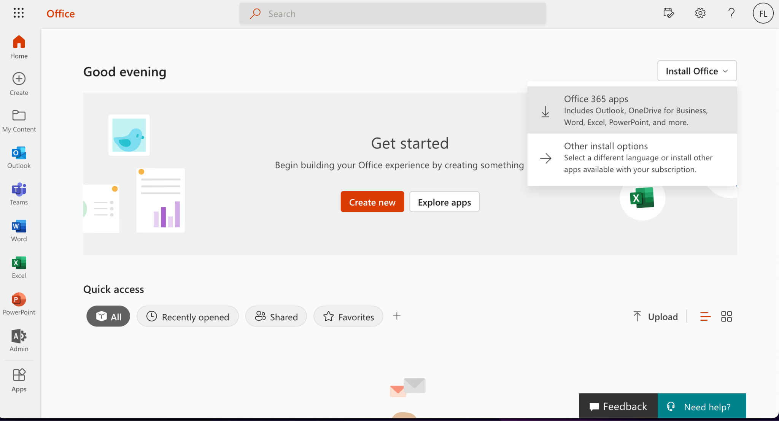

Click on install office and select office 365 apps

Next steps are specific to Mac / Windows using the Dev account :

1. For Mac, **don't download** from <https://www.office.com/?auth=2> (Entire office is downloaded, which is not required and also excel is not updated)

For Mac, download Excel from the App store (as it is updated one)

1. For Windows

Download from Microsoft 365 from : <https://www.office.com>

1. <https://www.office.com/?auth=2>

Or

1. <https://portal.office.com/account/?ref=MeControl>

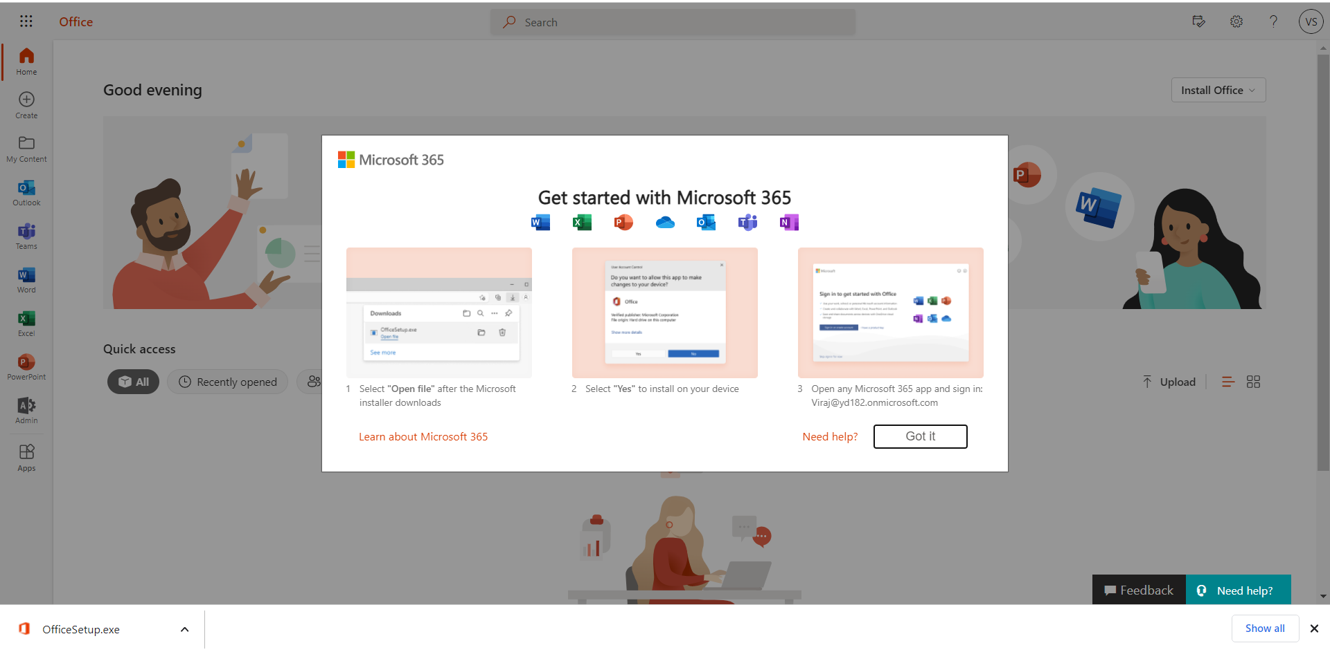

1. **Close the pre installed microsoft office apps on your windows system if they are open**
2. **Please uninstall any previous office application that you have on your system**
   1. if you have them pre installed with your laptop dont worry you can again install them when the trial ends by signing into your previous microsoft account
   2. After signing in click on services and subscription tab you will be able to see the products that you have purchased click on install and follow the installation steps

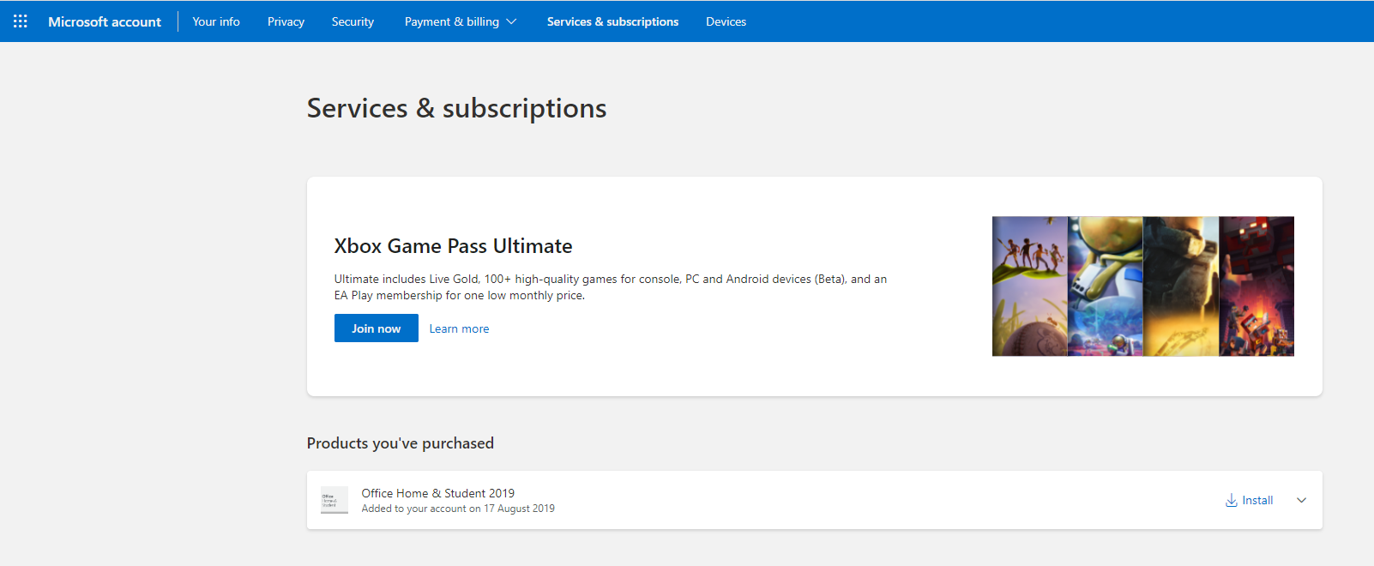

1. Click on the exe file and start the installation process,It will install respective packages

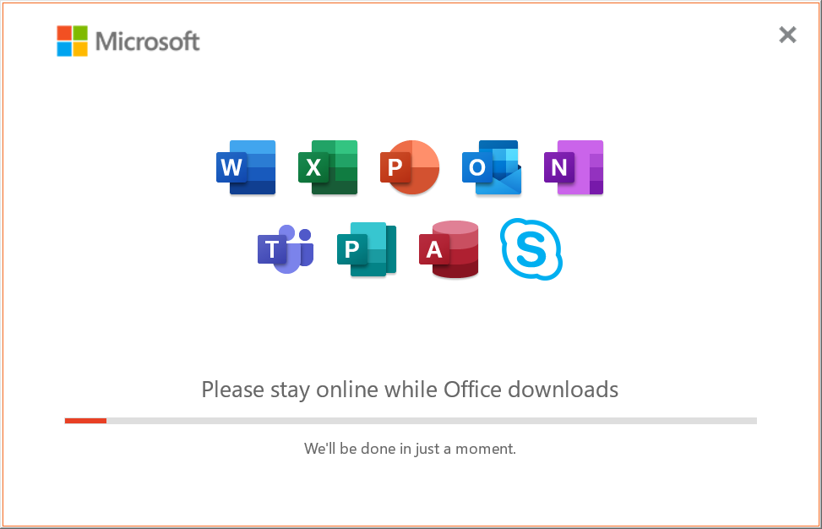

1. Once installed in search box type office and open the office application
2. At the top right click on the account manager button (right side of setting button)
3. Select switch account if you already have an account logged in or select sign in
4. Under use a different account select work or school microsoft account and click on continue
5. Use the developer email and password to sign in
6. Once everything is done you will get below interface

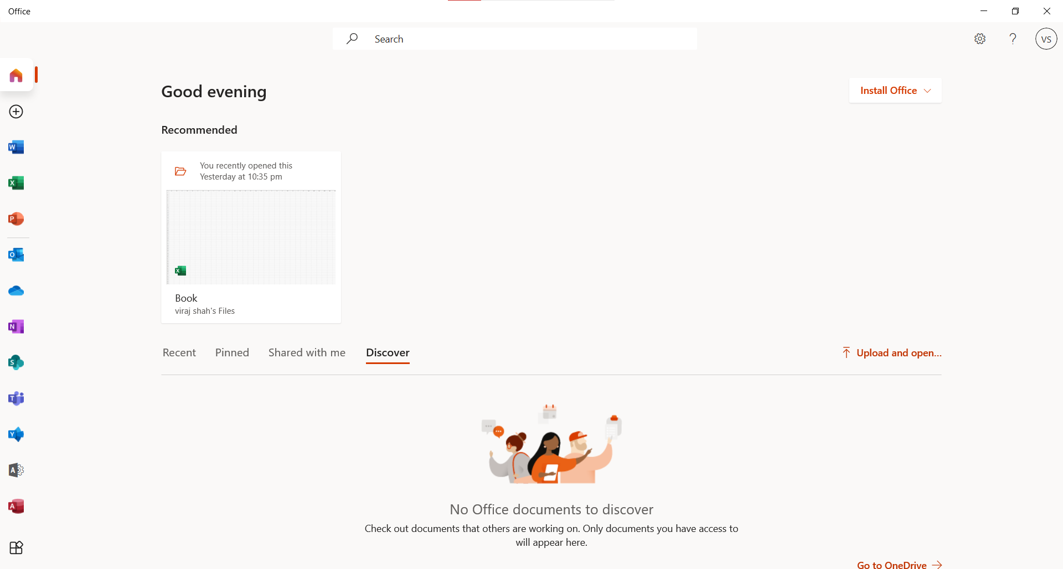

When you open up Excel it should display Excel Microsoft 365 as shown below

